South Hero Village Park – Groundbreaking Spring 2026
A new gathering place shaped by the community, for the community
The Town of South Hero is proud to announce that ground breaking of our long-planned Village Park which will officially begin in Summer 2026. This project is the result of several years of steady work by volunteers, town officials, and residents who shared ideas, participated in surveys, and helped shape a vision for a park that reflects the character and needs of our community.
From the earliest stages, the South Hero Recreation Commission focused on doing this the right way: reviewing town survey maps and property records, working with local engineers, and holding public meetings to keep progress moving and transparent. Community surveys — especially outreach to families and parents — helped define the features residents most want to see in this space.
The committee also consulted with the landowner interested in donating property, as well as experienced landscape professionals, walking the property to understand how the land can best be used while preserving the natural beauty that makes South Hero special. Careful thought has gone into future needs such as lighting, signage, additional park amenities, accessibility, landscaping, and parking.
A major priority throughout this effort has been responsible financial planning. Volunteers researched grant opportunities, funding deadlines, and potential revenue sources to ensure the park can be built and maintained without creating additional burden on local taxpayers. Estimated long-term needs such as grounds upkeep, trash removal, security, benches, and shaded seating areas have all been considered as part of the planning process.
While final design details will be shared as plans are completed, the park is being designed to support:
- Family recreation and informal play
- Community gatherings and events
- Comfortable, shaded seating and landscaped areas
- Open, flexible space for residents of all ages
- A setting that fits naturally into South Hero’s landscape
- A space large enough to offer more park amenities as funding (donations or grants) become available.
Planning images and concept ideas gathered during the process have helped the committee visualize how these elements can come together into a welcoming and versatile community space (see below).
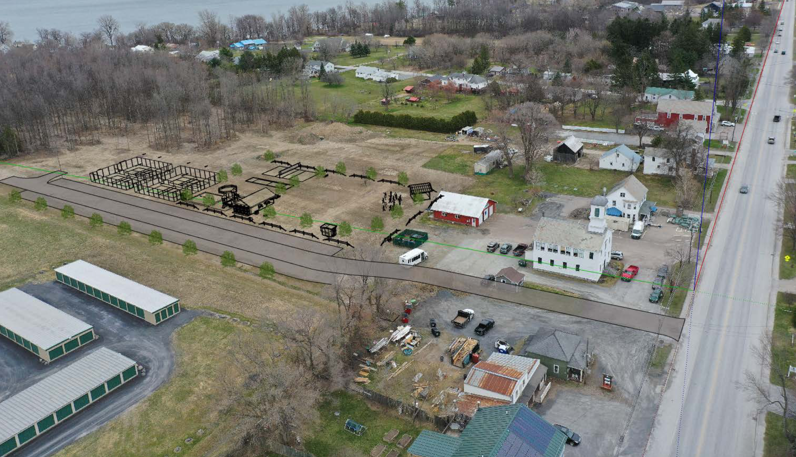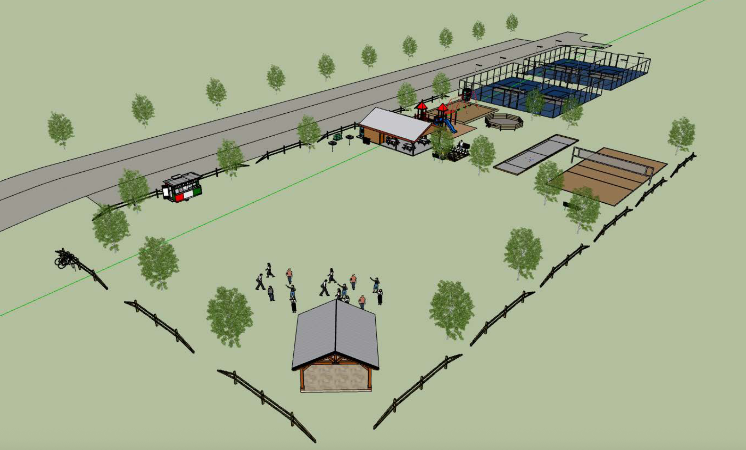
Importantly, the park will be built using a phased approach. This allows the town to prioritize essential features first, align construction with available funding, and adapt future phases based on how residents use and enjoy the park over time. This ensures the park can grow thoughtfully alongside the community.
A town park is more than a green space. It is a place where neighbors meet, children play, families gather, and community pride grows. This park represents an investment in South Hero’s quality of life for generations to come.
As we approach Spring 2026, residents can look forward to updates on final designs, construction, and opportunities to be involved as this vision becomes reality.
The South Hero Village Park is truly a park built by the community, for the community — and we look forward to breaking ground together.

