

**Construction Update**

**Colchester Exit 17**

**Colchester NH 028-1(31)** [National Highway]

**DATE:** Friday, August 23, 2024

**SPECIAL ANNOUNCEMENT:** In observance of Labor Day, crews will be off-site Friday, August 30, by 12 p.m. and will return on-site at 7 a.m. on Tuesday, September 3.

**TRAFFIC IMPACT AND DURATION:** From Monday, August 26, through Friday, August 30, between 9 a.m. and 3 p.m., there will be alternating one-way traffic controlled by flaggers on U.S. Route 2 (U.S. 2) between the bridge over Interstate 89 (I-89) and Jasper Mine Road.

I-89 will be reduced to a single lane in both directions near Exit 17. The single-lane closures will occur during off-peak hours: 6 a.m. to 3 p.m. on I-89 northbound and 9 a.m. to 8 p.m. on I-89 southbound. The I-89 northbound off-ramp slip lane for turning right onto U.S. 2 westbound will be closed between 9 a.m. and 3 p.m. Motorists will be able to make a right turn at the signalized intersection of the I-89 northbound off-ramp and U.S. 2.

*Motorists are advised to slow down and use caution while traveling through the work zone. Delays along U.S. 2 are expected; please allow additional travel time through the area.*

**CONSTRUCTION ACTIVITIES:** Crews will continue widening along U.S. 2 between the bridge over I-89 and Jasper Mine Road to support the construction of the new Exit 17 southbound on-ramp from U.S. 2 westbound. Additionally, Green Mountain Power will install temporary streetlights along this segment of U.S. 2.

Crews will conduct work to widen the I-89 northbound off-ramp and continue driving piles for the new U.S. 2 bridge over I-89, with work performed adjacent to the I-89 northbound and southbound lanes. They will install formwork and reinforcing steel for the new pier footing in the I-89 median. Additionally, crews will construct the new I-89 southbound on-ramp from U.S. 2 westbound and the gravel wetlands between the Exit 17 southbound off-ramp and I-89, working off the roadway.

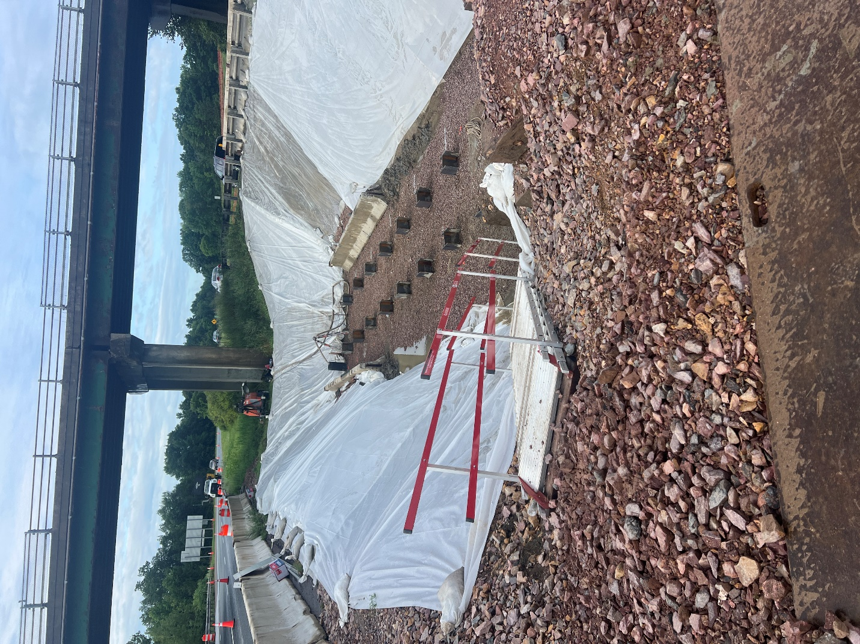

*Crews drive piles for the new pier footing in the interstate median near Exit 17 in Colchester, VT.*

**LOCATION:** The segment of U.S. 2 starting just east of Jasper Mine Road and extending just under a half mile east to its intersection with U.S. 7 at Chimney Corner. The segment of U.S. 7 starting just south of the Shell Gas Station/Simon’s Chimney Corner Store and extending just over a half mile north to its intersection with Wiley Road. The Exit 17 interstate ramps and the portion of I-89 bounded by them.

**PROJECTED COMPLETION:** Summer 2026

[Project Website](https://vtrans.vermont.gov/projects/colchester-exit17)

[Project Factsheet](https://vtrans.vermont.gov/sites/aot/files/2024-06/Colchester%20Exit%2017%20Project%20Factsheet.pdf)

[Sign up for Project Updates](https://lp.constantcontactpages.com/sl/JqQ3mdi?source_id=e87589a5-f6f2-4852-b484-fbeb0acde56a&source_type=em&c=vLjRZzegX4EcaL2Fdz1gOecvwX_JgQ8gTp27li2EcxIXaK5ifuvwJQ==)

**CONTACT US:**

24-Hour Project Hotline – 802-595-4399

Email – [info@ColchesterExit17.com](mailto:info@ColchesterExit17.com)

*The Colchester Exit 17 Project will be completed in six phases over three construction seasons, beginning in Spring 2024 and continuing through Summer 2026.*