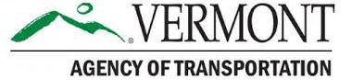

Construction Update
Colchester Exit 17
Colchester NH 028-1(31)
DATE: Friday, July 12, 2024
TRAFFIC IMPACT AND DURATION: From Monday, July 15, through Friday, July 19, between 6 a.m. and 8 p.m., there will be a lane shift to the southern side of the roadway on U.S. Route 2 (U.S. 2) west of the bridge over Interstate 89 (I-89).
Traffic along U.S. Route 7 (U.S. 7) between the Shell Gas Station and Wiley Road will be shifted to the eastern side of the roadway. Outside of peak hours, between 9 a.m. and 3 p.m., there will be alternating one-way traffic along this segment of U.S. 7.
There is potential for lane width reductions along the I-89 northbound off-ramp.
Motorists are advised to slow down, use caution, and expect minor delays while traveling through the work zone.
CONSTRUCTION ACTIVITIES: Crews will continue work to widen the roadway on U.S. 2 west of the bridge over I-89, near the future I-89 southbound on and off ramps. Crews will continue working along the west side of U.S. 7 to widen the roadway between the Shell Gas Station and Wiley Road. Crews will assemble crane equipment adjacent to the I-89 northbound off-ramp.
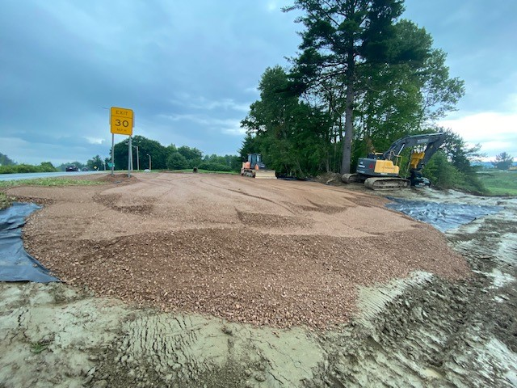
Crews begin to install a crane pad for crane equipment next to the I-89 Exit 17 northbound off-ramp.
LOCATION: The segment of U.S. 2 starting just east of Jasper Mine Road and extending just under a half mile east to its intersection with U.S. 7 at Chimney Corner. The segment of U.S. 7 starting just south of the Shell Gas Station/Simon’s Chimney Corner Store and extending just over a half mile north to its intersection with Wiley Road. The Exit 17 interstate ramps and the portion of I-89 bounded by them.
PROJECTED COMPLETION: Summer 2026
Project Website
Project Factsheet
Sign up for Project Updates
CONTACT US:
24-Hour Project Hotline – 802-595-4399
Email – info@ColchesterExit17.com
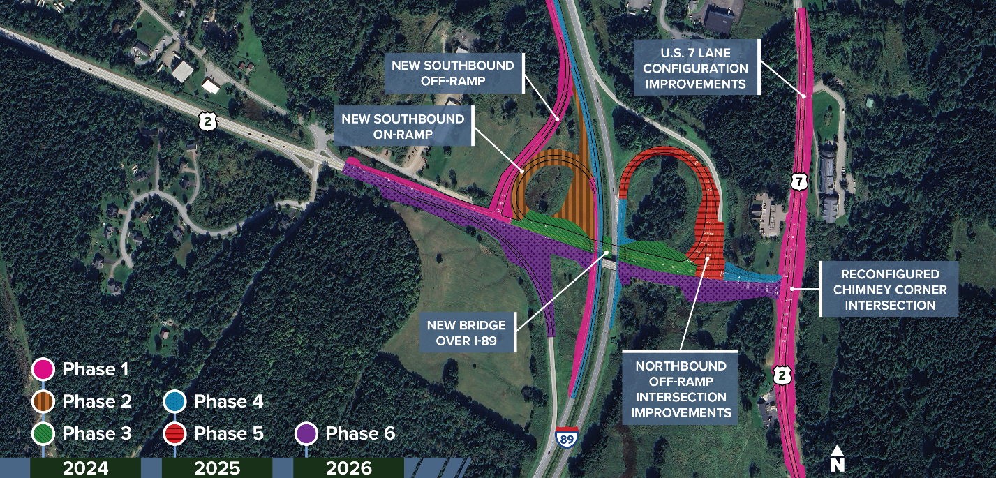
The Colchester Exit 17 Project will be completed in six phases over three construction seasons, beginning in Spring 2024 and continuing through Summer 2026.

