Construction Update
Colchester Exit 17
Colchester NH 028-1(31)

DATE: Friday, May 10, 2024
TRAFFIC IMPACT AND DURATION: Monday, May 13 through Friday, May 17, between 9 a.m. and 3 p.m., there will be lane shifts along U.S. Route 7 (U.S. 7) between just south of the Shell Gas Station/Simon’s Chimney Corner Store to its intersection with Wiley Road to facilitate independent utility work.
CONSTRUCTION ACTIVITIES: Next week, during the daytime hours, independent utility companies will be on-site conducting utility relocations in preparation for the start of construction.
Crews will be on-site Monday through Friday, between 7 a.m. and 7 p.m., to install erosion prevention and sediment control measures off the roadway throughout the project area. There is also potential for crews to install silt fencing off of the roadway along U.S. 7 within the project limits.
Nighttime construction activities along U.S. 7, starting just south of the Shell Gas Station/Simon’s Chimney Corner Store and extending north to Wiley Road, are anticipated to begin at the end of May/early June of 2024. This work will take place Sunday through Thursday between the hours of 8 PM and 6 AM. Additional information and traffic impacts will be provided closer to the start of construction.
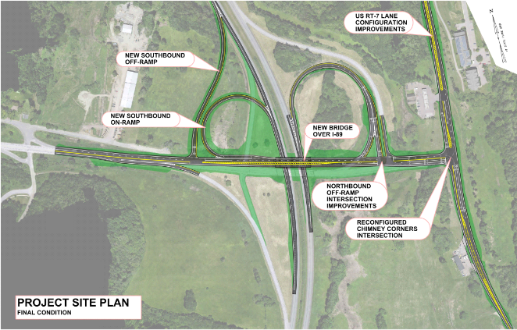
LOCATION: The section of U.S. 2 starting just east of Jasper Mine Road and extending just under a half mile east to its intersection with U.S. 7 at Chimney Corners. The section of U.S. 7 starting just south of the Shell Gas Station/Simon’s Chimney Corner Store and extending just over a half mile north to its intersection with Wiley Road. The Exit 17 interstate ramps and the portion of I-89 bounded by them.
PROJECTED COMPLETION: Summer 2026
Project Factsheet
Sign up for Project Updates
CONTACT US:
24-Hour Project Hotline – 802-595-4399
Email – info@ColchesterExit17.com

