DRAFT
PUBLIC ACCESS AGREEMENT
(Please note: in the end there will be 3 separate agreements, one with each landowner. All the landowner names and addresses are below for now, but will be split into 3 different documents once the remainder of the agreement language is agreed upon by all parties)
THIS AGREEMENT is entered into by and between (Steve and Kelly Robinson/Isle of Patmos Lodge #17 / Jonathan and Alice Wells) (referred to elsewhere in this document as the “Landowner”), The Town of South Hero (referred to elsewhere in this document as “the Town”), and South Hero Land Trust (referred to elsewhere in this document as the “Land Trust”) for the specific purpose of allowing public recreational use of a trail on a piece of property in the town of South Hero, Vermont.
WHEREAS, the Town and Land Trust wish to provide a safe and accessible recreational experience for the public by constructing and maintaining a recreational trail on the Property (referred to elsewhere in this document as the “Recreational Trail”).
NOW THEREFORE, the Landowner, the Town, and Land Trust agree to the following:

DEFINITIONS
  - “Recreational Use” means the enjoyment of the trail by members of the public, under the types of allowed uses as stated in Section VI.

  - The “Property” refers to a piece of property located at
    - 354 Route 2 South Hero, VT, 05486 (Robinson)
    - 32 South Street South Hero, VT, 05486 (Wells)
    - 40 South Street, South Hero VT 05486 (Masons)
identified on the tax parcel maps for the Town of South Hero as parcel number
      - RTE353 (Robinson)
      - SS032 (Wells)
      - SS040 (Masons)
  - The “Recreational Trail” or “the trail” shall be defined as the physical structure and function of the public access path on the property.

  - The “Trail Corridor” shall be defined as the width of the area within which the trail (the tread) itself can be located, the location of which is indicated in the map(s) in Section XII.
  - The “Trail Management Plan” shall be defined as the companion document to this trail agreement, updated regularly with agreement from all parties, which will go into the specifics of trail maintenance tasks, and who will be responsible for them.

OBLIGATIONS OF THE LANDOWNER

  - The Landowner shall allow the Town and Land Trust to construct and maintain the Recreational Trail on the Property as planned with the consent of the Landowner.

  - The Landowner shall allow the public to utilize the trail built and maintained by the Town and Land Trust for Recreational Use without charging a fee for visiting or using the property.

  - The Landowner shall notify the Town and Land Trust of any upcoming forest management, agricultural use, hunting use, or other land management activities which would necessitate the temporary closure of all or part of the Recreational Trail.

  - The Landowner shall notify the Town and Land Trust of any changes in the Landowner’s contact information listed at the bottom of this agreement.
  - The Landowner agrees to notify the Town and Land Trust of any land transfer 30‐days ahead of the transfer.
  - The Landowner shall notify the Town and Land Trust of any problems or issues arising from Recreational Use.

OBLIGATIONS OF THE TOWN AND LAND TRUST
The Town of South Hero (Town) and South Hero Land Trust (Land Trust) accept joint responsibility for the following:
  - The Town and Land Trust shall construct and maintain the Recreational Trails, in a safe manner utilizing best practices that allow for Recreational Use by the general public.

  - Before constructing any new Recreational Trail(s) or rerouting on the property, the Town and Land Trust shall examine the route of the proposed Recreational Trail(s) with the Landowner, in order to confirm the route is acceptable to the Landowner.

  - Prior to commencing construction of any new Recreational Trail(s) on the Property, the Town and the Land Trust shall be solely responsible for obtaining any required local, state, or federal land use permits. The Landowner agrees to cooperate with the Town and Land Trust by signing any permit applications or taking any other actions that will facilitate the Town’s or Land Trust’s acquisition of a permit.

  - The Town and Land Trust shall notify the Landowner of any changes in the Town’s contact information listed at the bottom of this agreement, including the name of the primary contact person for the Land Trust and the Town.

  - The Town and Land Trust shall notify the public through all available channels when the Recreational Trail is closed due to trail conditions, landowner events, trail management operations, farming operations, hunting, etc.

  - The Town and Land Trust shall communicate with the Landowner their construction/maintenance plans for the Trail, on at least an annual basis.

  - The Town and Land Trust shall encourage all users of the Recreational Trail to report any illicit uses or activities on the Property which are not consistent with the Landowner’s management plan or wishes.

  - The Town and Land Trust shall respond promptly to any Landowner concerns arising from Recreational Use on the Property.

TRAIL LOCATION & SPECIFICATIONS
  - The tread of the trail shall not exceed [6] feet in width unless dictated by special circumstances. In which case, the Landowner, Town, and Land Trust shall discuss specifics and determine a mutually agreeable solution.

  - The trail itself will be located within an agreed-upon corridor (see map) not to exceed [20] feet in width.

CONSTRUCTION & MANAGEMENT
  - The Recreational Trail shall be built to accommodate Recreational Use.
  - The Town and Land Trust shall be permitted to build footbridges, install culverts, grade the tread, install stone or take other steps to improve drainage and durability of the Recreational Trail.

  - The Town and Land Trust shall be permitted to remove any downed trees, dead fall and other vegetation that obstructs or otherwise threatens the trail corridor. Removal of trees and shrubs up to [6 in] caliper shall be permissible to create a usable trail corridor. The use of chainsaws and motorized equipment such as weed trimmers and leaf blowers shall be permitted as part of trail construction and maintenance.

  - The Town and Land Trust shall be permitted to erect and maintain signage for the Recreational Trail and use a system of trail blazes to mark the trails. No nails or screws shall be inserted into living trees on the property for the purpose of signage or other trail infrastructure.

  - The Town and Land Trust shall be permitted to erect and maintain education signage along the trail to inform the public about the history of the land, the ecology, and other topics. All educational signage must be approved by the landowner before being constructed.

  - The Landowner shall not obstruct the Recreational Trail.

  - The Town and Land Trust shall have the discretion to close or otherwise limit public access to all or part of the Recreational Trail during construction or maintenance activities, as well as seasonally during the spring to prevent erosion and trail damage.

  - The Landowner shall have the discretion to close the trail on a short term basis, during periods in which public access may interfere with agricultural or forestry use, or hunting, or pose a safety risk to the public.

  - The Landowner, Land Trust, and the Town shall collaborate with each other before closing the trail for any period of 24 consecutive hours or more.

PUBLIC ACCESS AND ALLOWED USES

  - The Recreational Trail will be open to the public. The hours for public trail use shall be considered dawn until dusk, with a carry in-carry out policy.

  - Before the trail is opened to the public the management plan shall be created and agreed upon by all parties named in this document.

  - Public access to the Property will be limited to the trail corridor.
  - The trail will be open for the public to use for low-impact, non-motorized recreation, including, pedestrian, xc ski, snowshoe, horseback riding, and wheelchair users on the trail. Hunting, fishing, foraging, and camping by the public will not be allowed. Public use of the trail via motorized vehicles will also not be allowed, except for motorized wheelchairs.

  - Bicycles will be permitted on the trail on a limited basis. If bicyclists become a detriment to agricultural activities, safety of recreation users, or to the ecology of the area, this policy can be revisited and changed if there is consensus agreement of the Landowner, Land Trust, and the Town.

  - The Landowner, Land Trust, and the Town will be allowed to use motorized vehicles on the trail for maintenance and construction, and other land management/farming purposes.

  - Any other use of motorized vehicles on the trail needs to be reviewed and discussed between the Landowner, the Town, and the Land Trust.
  - Dogs are permitted on the trails as long as they are leashed and responsibly cleaned-up after. If dog walkers or dog use become a detriment to agricultural activities, safety of recreation users, or to the ecology of the area, this policy can be revisited and changed if there is consensus agreement of the Landowner, Land Trust, and Town.

LENGTH OF AGREEMENT

  - This agreement shall become effective when signed by the Town, the Land Trust, and the Landowner (the “Effective Date”). Because the Town and Land Trust intend to utilize public funding for construction or maintenance, this agreement shall remain in effect for a period of [10] years from the Effective Date.
  - This agreement may be modified, renewed, or replaced with a more formal Trail Easement, upon written agreement by the Landowner, Land Trust, and the Town.

GENERAL PROVISIONS

  - Neither this Agreement nor any use of the Recreational Trail established pursuant to this agreement shall, under any circumstances, entitle [The Town of South Hero], South Hero Land Trust, or any other Holder, or any member of any one or more such organizations, to claim any dedication, any right of adverse possession, any prescriptive easement, or any similar right with respect to any portion of the Landowner’s property.

  - Neither this agreement, nor any right or duty of any party, may be transferred, assigned, conveyed or contracted without the prior written permission of the other parties.

CONFLICTS

  - Should a conflict with any aspect relating to the trail be identified by the Landowner, Land Trust, or the Town, the identifying party should contact the others in a timely and respectful manner. Conflicts will be reviewed and analyzed by all parties, and through in-person meetings, will be discussed and resolved. Should a conflict prove difficult to resolve, an outside mediator will be approached to help resolve the issue.

LIABILITY

  - The Town and the Land Trust shall hold the Landowner harmless against all loss and liability to public users of the Recreational Trail and indemnifies the Landowner from the same.

  - In the event (a) the Landowner Liability Protection afforded by 10 V.S.A. 20 or 12 V.S.A. 203 is repealed or altered in a manner which materially increases, in Landowner’s reasonable opinion, Landowner’s potential liability to public users of the Recreational Trail, and (b) No other statute or law affords the Landowner, in Landowner’s reasonable opinion, liability protection which is substantially similar to that now afforded by 10 V.S.A. 20 or 12 V.S.A. 203; and (c) the Land Trust nor the Town elect not to provide reasonable insurance coverage or otherwise agree to hold Landowner harmless against potential liability to public users of the Recreational Trails, then this agreement shall terminate and be rendered null and void.

[Signature Page to Follow]

- SIGNATURES
The signatories below agree to the terms and conditions of this Agreement.
LANDOWNER -
Name: _______________________ Signature_____________________Date:_______

Name: _______________________ Signature_____________________Date:_______

Mailing Address:
Email Address:
Telephone Number:

HOLDER - Town of South Hero

Name: _______________________ Signature_____________________Date:_______

Title: Selectboard Chairman
Mailing Address: P.O. Box 175, South Hero, VT 05486
Email address:
Telephone number:

TRAIL MANAGER - South Hero Land Trust

Name: Emily Alger______________ Signature_____________________Date:_______

Title: Executive Director
Mailing Address: PO Box 455, South Hero, VT 05486
Email address: emily@shlt.org
Telephone number: 802 372-3786

–
EFFECTIVE START DATE OF AGREEMENT: ___________________

- Attachments
MAP(s) OF TRAIL CORRIDOR
Orange = trail corridor
Map #1: Trail Map
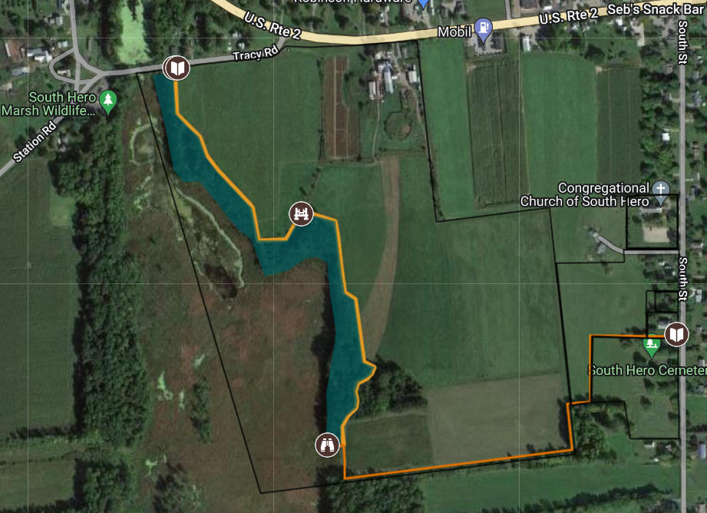

Map #2: Wells and Masonic Lodge
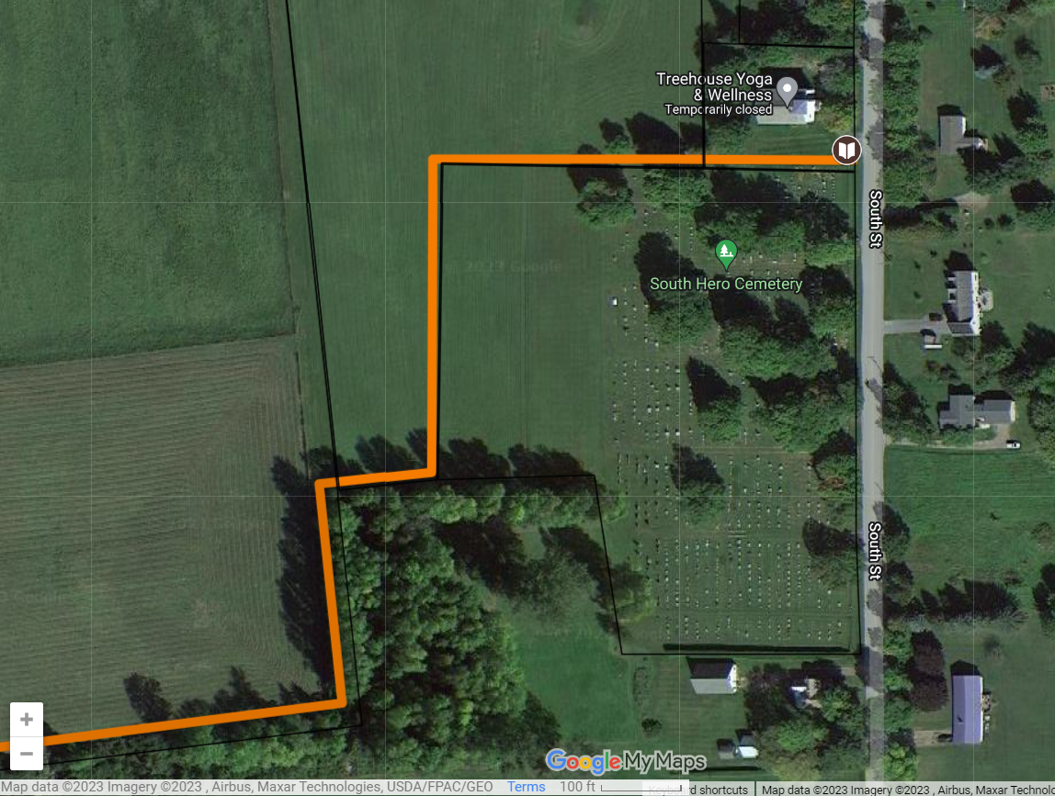

Map #3: Islandacres Property, Southern Section
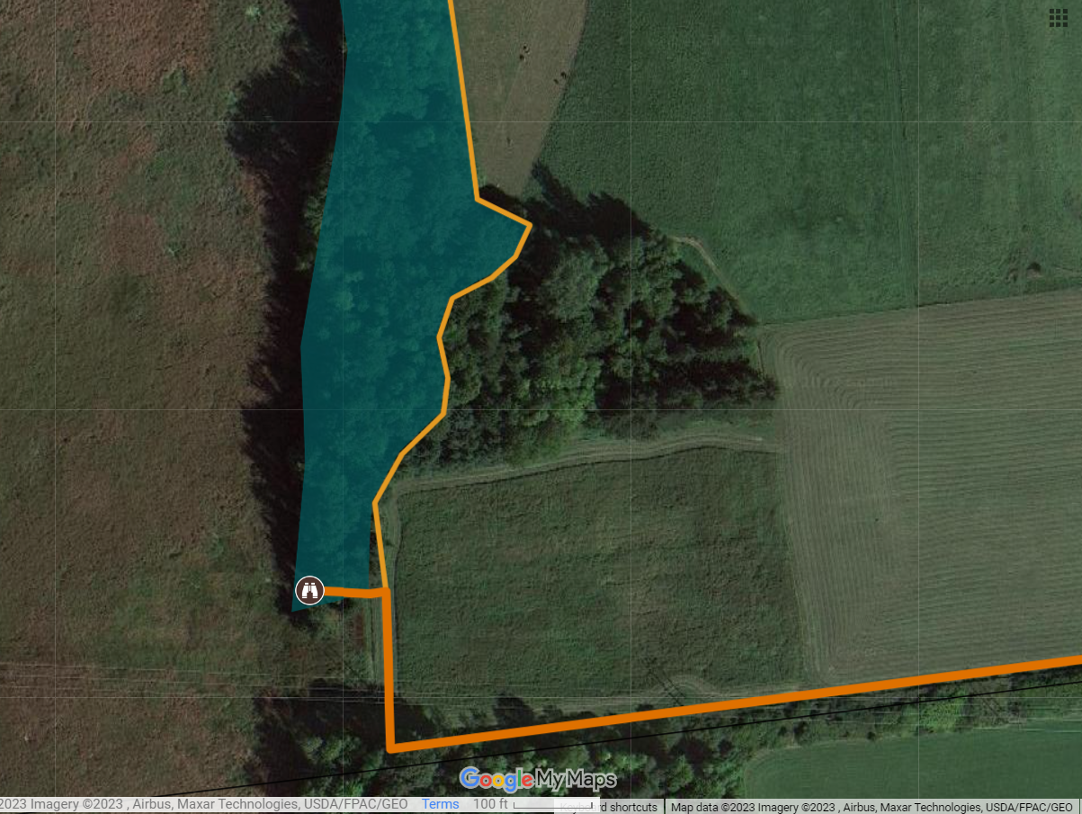

Map #4: Islandacres Property, Northern Section
