Construction Update
South Hero Intersection Improvement Project
South Hero STP HES 028-1(22)

DATE: Friday, April 22, 2022
TRAFFIC IMPACT AND DURATION:
Please be advised, that speeds are reduced to 25 mph along U.S. Route 2 (U.S. 2) and Vermont Route 314 (VT 314) within the project limits. The project limits extend along U.S. 2 for approximately 1,300 feet from just north of the St. Rose of Lima church to just north of Sunrise Drive and along VT 314 to just west of the Mobil Station.
Monday, April 25 through Friday, April 29, between the hours of 6:30 a.m. and 5:30 p.m., motorists should expect one lane with alternating two-way traffic on U.S. 2 between VT 314 and the St. Rose of Lima Church in South Hero. Flaggers will be present to assist motorists throughout the work zone.
Motorists are reminded to stay alert and slow down through the work zone.
CONSTRUCTION ACTIVITIES:
Early next week, crews will continue to clear trees and brush along the east side of U.S. 2 in preparation for the construction of the on-site detour. Next week, crews will begin work on the temporary relocation of the existing stream in preparation for the replacement of the existing culvert.
Clearing and grubbing being completed on the east side of U.S. Route 2.
LOCATION: The South Hero Intersection Improvement Project is located at the intersection of U.S. Route 2 (U.S. 2) and Vermont Route 314 (VT 314) in South Hero, Vermont. The U.S. 2 project limits extend from just north of the St. Rose of Lima church to approximately 1,300 feet to the north, halfway between Sunrise Drive and the Fish and Wildlife Access Road. The VT 314 project limits extend from its intersection with U.S. 2 to just west of the Mobil Station.
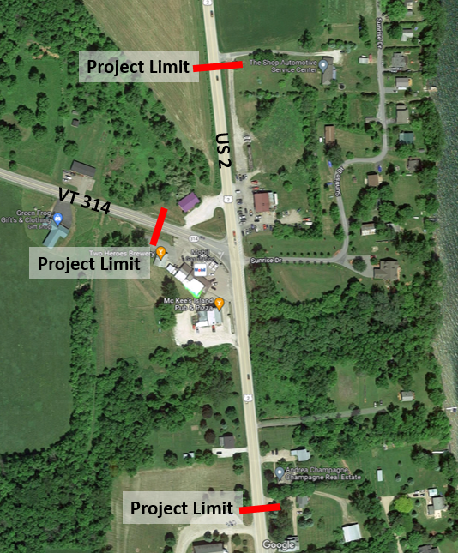
PROJECTED COMPLETION: December 2022

