Construction Update South Hero Intersection Improvement Project
South Hero STP HES 028-1(22)
DATE: Friday, April 15, 2022 TRAFFIC IMPACT AND DURATION:
Please be advised, that speeds are reduced to 25 mph along U.S. Route 2 (U.S. 2) and Vermont Route 314 (VT 314) within the project limits. The project limits extend along U.S. 2 for approximately 1,300 feet from just north of the St. Rose of Lima church to just north of Sunrise Drive and along VT 314 to just west of the Mobile Station.
Monday, April 18 through Friday, April 22, between the hours of 6:30 a.m. and 5:30 p.m., motorists should expect intermittent shoulder and lane closures along U.S. 2 and VT 314 in South Hero. Flaggers will be present to assist motorists throughout the work zone.
Motorists are reminded to stay alert and slow down through the work zone.
CONSTRUCTION ACTIVITIES: Crews will be on-site setting up erosion prevention and sediment control measures including the project demarcation fence which marks the limits of construction throughout the project area.
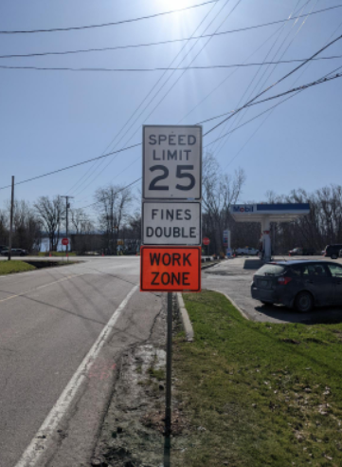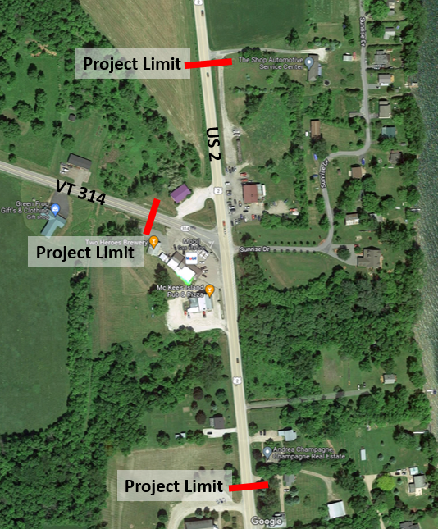
Speeds have been reduced to 25 mph along U.S. 2 and VT 314 in South Hero
LOCATION: The South Hero Intersection Improvement Project is located at the intersection of U.S. Route 2 (U.S. 2) and Vermont Route 314 (VT 314) in South Hero, Vermont. The U.S. 2 project limits extend from just north of the St. Rose of Lima church approximately 1,300 feet to the north, halfway between the Sunrise Drive intersections. The VT 314 project limits extend from its intersection with U.S. 2 to just west of the Mobile Station.

PROJECTED COMPLETION: December 2022

